[Form 6]
Those who qualified for the deduction includes the applicant and family member(s) living with him/her in Japan who, at the time of application, is in the midst of a convalescence period of six months or longer or requires a convalescence period of six months or longer.
出願時において6ヵ月以上にわたる長期療養中の者又は療養を必要と認められる者が対象です。
Please read instructions on the reverse before filling out this form. 裏面を参照して記入願います。
(Year) /(Month) /(Day)
Certificate of Medical Long-Term Care Expenses
長期療養費支出状況証明書

【TO BE COMPLETED BY STUDENT】学生記入欄
Affiliation 所属 | Kyoto University 京都大学
Faculty/Graduate school 学部・研究科 |  | Student No. 学生番号 | Name 氏名 (Applicant 申請者)
This is to certify that the expenses below were incurred by the following care recipient for the period stated below. I will use this form as part of application for (*Admission fee Exemption・Admission fee Deferment・Tuition Exemption).
（* 入学料免除・入学料徴収猶予・授業料免除）の申請に係る資料として、以下の事項について証明をお願いいたします。

【TO BE COMPLETED BY PHYSICIAN】診療機関記入欄
NOTE: If the applicant is unable to have this form completed by medical institutions, etc., please refer to the column [For those unable to have this form completed by medical institutions, etc.] on the reverse.
診療機関で証明が取れない場合は、裏面の【診療機関で証明が受けられない場合について】を参照してください。

Name of Care Recipient  療養者氏名 |  |  |  |  |  |  | Name of illness, etc  病名等
Convalescence  Period  療養期間 |  | ・Date of initial visit/ treatment 初診日  (Year 年) /(Month 月) /(Day 日)  ・Expected date of the last medical care/treatment 療養終了予定日  * ・(Year 年) /(Month 月) /(Day 日)  ・Uncertain (but convalescence period of 6 months or longer  will be needed) 未定(6ヵ月以上の療養を必要とする) |  |  |  |  | Type of Health  Insurance  健康保険の種類 | * National Health Insurance 国保  Social Insurance 社会保険  Elderly Healthcare Programs 老人保健  Others その他（ ）
Statement of Medical Care Expenses 療養費記入欄
Category  区 分 |  | ①  Hospitalization Costs |  | ②  Outpatient Costs | ③  Nursing Care Service  (Self-paid)  介護サービス  （自己負担分） | ④  Others  その他 | ⑤  Amount of Reimbursement  (High-cost Medical Care Benefit, etc.)  補填される金額（高額療養費等） |  |  | Differences  差引金額  ①＋②＋③＋④－⑤
 |  | ☆If the applicant himself/herself fills in these sections(①～④), be sure to submit relevant receipts  (copies are acceptable).  本人が記入する場合、①～④は領収書の添付が必要 |  |  |  |  | Space for Physician to fill in  診療機関記入欄 | Space for Applicant to fill in  ☆If the applicant fills in this section(⑤), be sure to submit relevant notice(s), etc. (copies are acceptable).  本人記入欄  通知書等の添付が必要 |  | Differences  差引金額  ①＋②＋③＋④－⑤
(Year) /  (Month)  年月 | /
(Year) /  (Month)  年月 | /
(Year) /  (Month)  年月 | /
(Year) /  (Month)  年月 | /
(Year) /  (Month)  年月 | /
(Year) /  (Month)  年月 | /
(Year) /  (Month)  年月 | /
(Year) /  (Month)  年月 | /
(Year) /  (Month)  年月 | /
(Year) /  (Month)  年月 | /
(Year) /  (Month)  年月 | /
(Year) /  (Month)  年月 | /
Total 計
☆ The unit of currency in this form is Japanese yen. 単位：円
☆ DO NOT include hospital meal expenses, private room charges in hospitals and/or medical certificate fees, if any. 食事代・個室料・診断書料は除いて記入願います。
(VERIFICATION BY PHYSICIAN)
上記疾病に係る療養費について証明いたします。
令和 年 月 日 診療機関名
住 所
医師名等 印

＜Notes 注意事項＞ 1. Please circle applicable items in the section marked with an asterisk (*) ＊については、該当する項目に○をつけてください。
2. Make as many photocopies of this sheet as needed. 本用紙が複数枚必要な場合は、各自コピーしてください。

Instructions for Completing Certificate of Medical Long-Term Care Expenses [Form 6]
長期療養費支出状況証明書〔様式６〕の記入要領

If an applicant or his/her spouse or other family member(s) living in Japan with whom the applicant shares the same livelihood is in the midst of a convalescence period of six months or longer (or requires a convalescence period of six months or longer) at the time of application, please have this form completed by medical institutions, etc. and submit it to Kyoto University. Such form is regarded as a doctor’s certificate, and therefore it is unnecessary to submit a medical certificate written by a doctor. If there are any items such as the amount of reimbursement that medical institutions do not certify, attach applicable certificates or receipts listed in “For those unable to have this form completed by medical institutions, etc.” in the following box.
出願時現在で６ヵ月以上にわたる期間療養中の者（又は療養を必要と認められる者）がいる場合、病院・施設等の診療機関に願い出て本用紙に記入してもらい、証明を受けてください。なお、証明を受けた場合は、診断書の提出は不要です。ただし、補填される金額等、診療機関で証明できない箇所が一部ある場合は、下記の【診療機関で証明が受けられない場合について】のうち該当する書類を本紙に添付してください。
【For those unable to have this form completed by medical institutions, etc. 】
The applicant must complete this form and submit it with all of the following certificates and receipts.
○ Medical certificate from a doctor (issued within 6 months, stating that the medical treatment of 6 months or longer is needed)
○ Receipts issued within 12 months (copies are acceptable) (Please attach them to Form 11 “Pasting Sheet for Receipts, Etc.” by month. Exclude receipts that are irrelevant to the illness certified in the form.)
○ Certificate of reimbursement (stating the amount of reimbursement), if the care recipient has received insurance money or reimbursement of high-cost medical care expenses, etc. (copies are acceptable)

【診療機関で証明が受けられない場合について】
以下の書類をすべて添付し、申請者本人が記入してください。
○ 診断書（６ヵ月以上の療養が必要であることが明記されている直近6ヶ月以内発行のもの）
○ 最近１年以内の領収書（写）（月ごとに〔様式１１〕各種貼り付け台紙に貼り付けてください。なお、診断内容に関係のないものは除いてください。）
○ 保険金、高額療養費等の補填される金額がある場合は、振込通知等、その金額が分かる証明書（写）

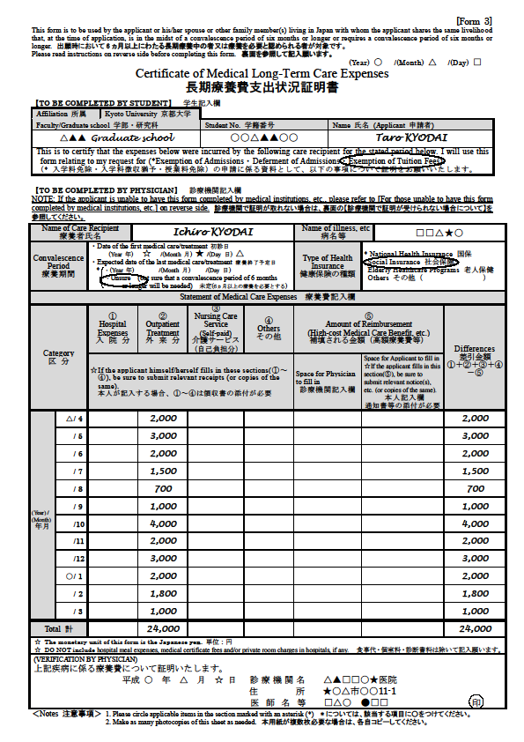
例
(Example)
Staple them per month

〔Form１１〕
Reimbursement

※Total
yen

〔Form１１〕

May
※Total
yen

〔Form１１〕

April
※Total
yen

Enter the amount of expenses paid within the last 12 months.
最近1年以内について記入してください。

[1st semester] From last April to March this year
[2nd semester] From last October to September this year
前期：昨年の4月から今年の3月 もしくは
後期：昨年の10月から今年の9月

※Total of each month

＜対象となる費目＞
①入院分
・病院、診療所への入院費用
②外来分
・医師又は歯科医師への診療・治療費
・マッサージ師、はり師、きゅう師、柔道整復師などの治療費（保険適用外のものは除く）
③介護サービス
・介護保険法により「要介護認定・要支援認定」を受けた人がそのサービスを利用した場合の自己負担額
・看護人に対して支払う費用（看護人に対する賄い費を含みます。）
④その他
・医師等の指示により、治療又は療養のために支出する医薬品代
・病院、診療所へ通院するために支出する交通費（必要不可欠と認められるものに限ります。）

- 食事代、診断書料、個室料は対象外

⑤保険金、高額療養費等
・①～④に対して補填されるもの
〈Applicable items〉
①Hospitalization Costs
・Expenses incurred for hospitalization at hospitals and clinics
②Outpatient Costs
・Medical care / treatment costs paid to physicians or dentists
・Expenses for treatment by massage professionals, acupuncturists, moxibustion practitioner, judo therapists, etc.（Except treatments not covered by insurance）
③Nursing Care Service
・Nursing care service costs incurred by those who have been recognized as requiring long-term care / support under the Long Term Care Insurance System
・Payments to nursing care workers (including charge for board)
④Others
・Costs of pharmaceutical products used for treatment or recuperation by physician’s order, etc.
・Costs of travelling to hospitals and clinics (only those that are deemed absolutely necessary)
※Board charges, medical certificate fees, and private room charges in hospitals are excluded.
⑤Insurance money and high-cost medical care expenses, etc.
・The amount of reimbursement for ①～④

※Total of a year
※If the total amount is less than ¥100,000, the medical long-term care deduction is not applicable, (However, expenses incurred at other medical institutions can be included as long as they are paid for the illness in question.)

