[Form2-3]

Pasting Sheet for the Certificate of Income
(the Certificate of Income and Withholding Income Tax：源泉徴収票)

Student No.: Student Name:

①Name on this certificate ( ) ②Relationship( )
③If you (or spouse) changed or left the job during the last year,
submit other documents which show the current income.
Paste the certificate of Income here
・Make a copy of your certificate (源泉徴収票) and paste it on this sheet.
・If the copy is A4 size or larger, attach or staple it to this sheet.
・If you have multiple certificates, you may attach them all to this sheet.
Total income:

yen

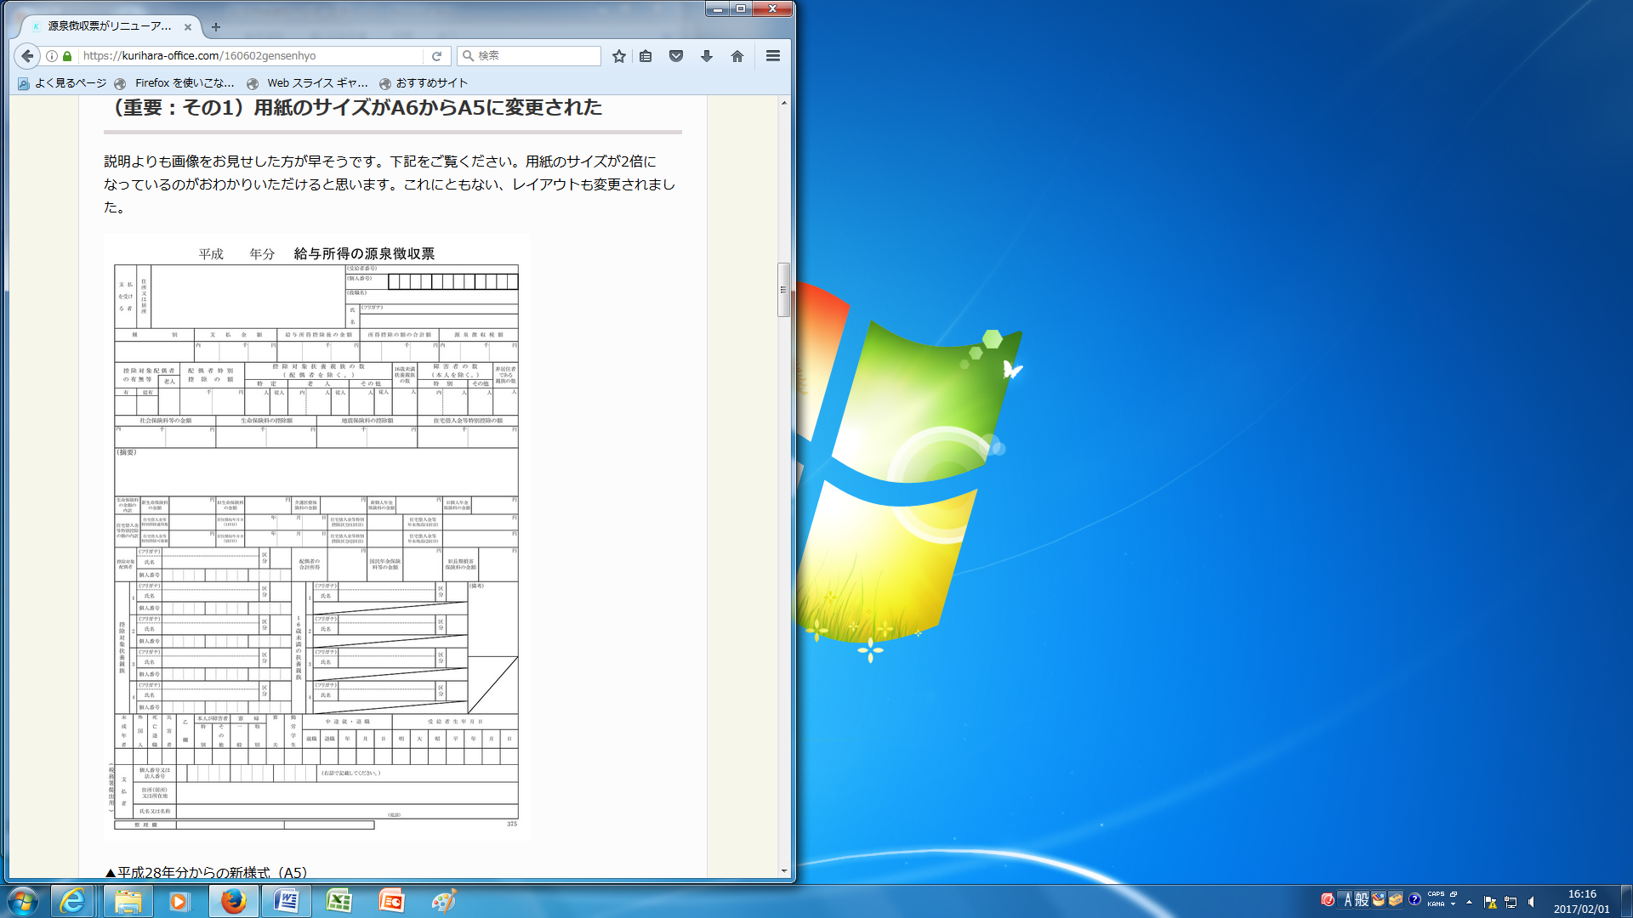
給与明細書
Pasting Sheet
for Pay statements
〔Form 2－2〕
Staple them together
〈the Certificate of Income and Withholding
Income Tax：源泉徴収票〉
〈How to attach〉

