[Form 2-2]

Pasting Sheet for Pay statements

Student No.: Student Name:

① Name on this statement （ ） ② Relationship（ ）
③ Company name （ ） ・If you are employed some places, please attach them to this sheet by each work place.
④ Employment date （ day month year）
⑤ A bonus Yes （ yen/year A ） ・ No
(If Yes, write the annual amount and submit copies of the document to show the amount)
⑥ Estimated annual income Calculate from salaries in the last three months and fill in the below.

D Total of the last 3 month
（except transportation fee）
３
(month)
E Estimated annual income
A Bonus
（if any）

12

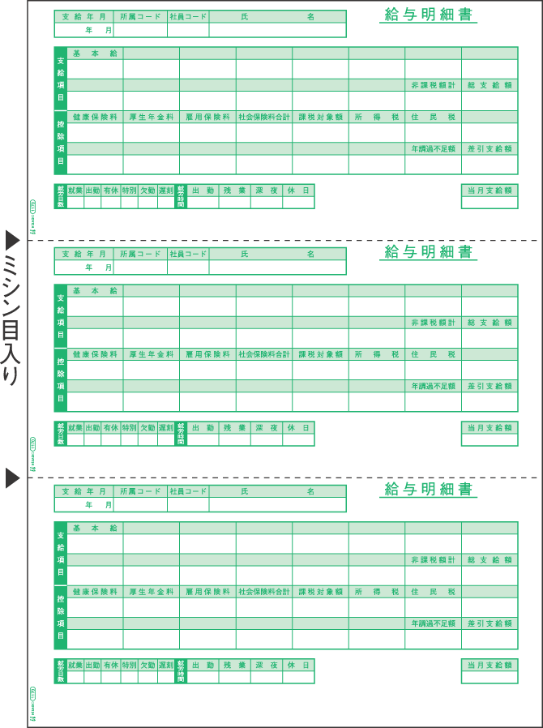
One-month income=
B (total amount)* – C (transportation fee)
month yen
month yen
month yen
D [total of 3 months] yen
【Note】
・Please submit 〔Form2〕instead if you cannot submit the last three months pay statements because of newly-employed, unstable jobs, lost of pay statements, or actual income will be different from the above calculation.

・Enter the amount which you calculated above to the application form (E should be matched)

* This is not ‘net payment amount’.
⑦ Paste the last three month pay statements(給与明細書) here

給与明細書
・If the copy is A4 size or larger, staple them on back
Pasting Sheet
for Pay statements
〔Form 2－2〕
Staple them together
of this sheet.
・Please paste them on this sheet if copies are smaller than A4 size.
Net payment amount
Transportation fee
Total amount
Example

通勤手当
C
B

