Instructions for Completing Certificate of Medical Long-Term Care Expenses [Form 6]
長期療養費支出状況証明書〔様式６〕の記入要領

If an applicant or his/her spouse or other family member(s) living in Japan with whom the applicant shares the same livelihood is in the midst of a convalescence period of six months (or longer or requires a convalescence period of six months or longer) at the time of application, please have this form completed by medical institutions, etc. and submit it to Kyoto University. Such form is regarded as a doctor’s certificate, and it is unnecessary to submit a medical certificate from a doctor. If there are any items such as the amount of reimbursement which medical institutions do not certify, attach applicable certificates or receipts listed in the below section of “For those unable to have this form completed by medical institutions, etc.”
出願時現在で６ヵ月以上にわたる期間療養中の者（又は療養を必要と認められる者）がいる場合、病院・施設等の診療機関に願い出て本用紙に記入してもらい、証明を受けてください。なお、証明を受けた場合は、診断書の提出は不要です。ただし、補填される金額等、診療機関で証明できない箇所が一部ある場合は、下記の【診療機関で証明が受けられない場合について】のうち該当する書類を本紙に添付してください。
【For those unable to have this form completed by medical institutions, etc. 】
The applicant must complete this form and submit it with all the following certificates and receipts.
○ Medical certificate from a doctor (of recent date, stating that a convalescence period of 6 months or longer is required )
○ Receipts issued within the last 12 months (Please attach them onto Form 11 “Pasting Sheet for Receipts, Etc.” on a monthly basis. Include only receipts for the stated illness on the form.) (or copies of the same)
○ Certificate of reimbursement (stating the amount of reimbursement), if the care recipient has received insurance money or reimbursement of high-cost medical care expenses, etc. (or copies of the same)

【診療機関で証明が受けられない場合について】
以下の書類をすべて添付し、申請者本人が記入してください。
○ 診断書（６ヵ月以上の療養が必要であることが明記されている最近の日付のもの）
○ 最近１年以内の領収書（写）（月ごとに〔様式１１〕各種貼り付け台紙に貼り付けてください。なお、診断内容に関係のないものは除いてください。）
○ 保険金、高額療養費等の補填される金額がある場合は、振込通知等、その金額が分かる証明書（写）

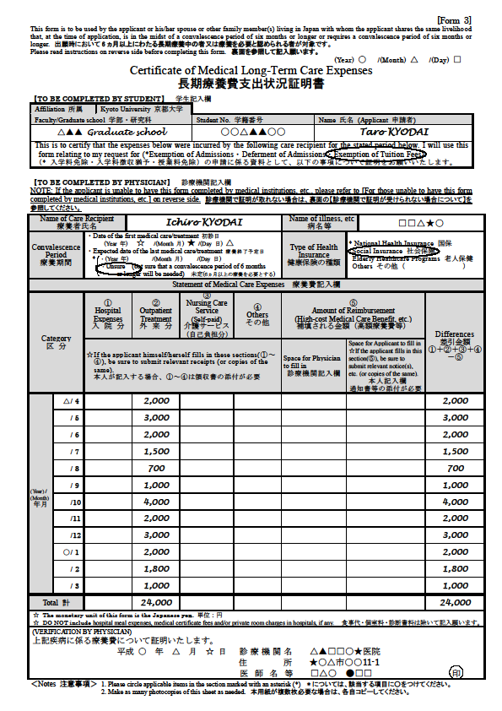

例
(Example)
Staple them per month

〔Form１１〕
Reimbursement

※Total
yen

〔Form１１〕

May
※Total
yen

〔Form１１〕

April
※Total
yen

Enter the amount of expenses paid within the last 12 months.
最近1年以内について記入してください。

[1st semester] From last April to March this year
[2nd semester] From last October to September this year
前期：昨年の4月から今年の3月 もしくは
後期：昨年の10月から今年の9月

※Total of each month

＜対象となる費目＞
①入院分
・病院、診療所への入院費用
②外来分
・医師又は歯科医師への診療・治療費
・マッサージ師、はり師、きゅう師、柔道整復師などの治療費（保険適用外のものは除く）
③介護サービス
・介護保険法により「要介護認定・要支援認定」を受けた人がそのサービスを利用した場合の自己負担額
・看護人に対して支払う費用（看護人に対する賄い費を含みます。）
④その他
・医師等の指示により、治療又は療養のために支出する医薬品代
・病院、診療所へ通院するために支出する交通費（必要不可欠と認められるものに限ります。）

- 食事代、診断書料、個室料は対象外

⑤保険金、高額療養費等
・①～④に対して補填されるもの
〈Applicable items〉
①Hospital Expenses
・Expenses incurred for hospitalization at hospitals and clinics
②Outpatient Treatment
・Medical care / treatment costs paid to physicians or dentists
・Expenses for treatment by massage professionals, acupuncturists, moxa-cauterizers, judo therapists, etc.（Except treatments not covered by insurance）
③Nursing Care Service
・Payments to nursing care workers (including charge for board)
・Out-of-pocket nursing care service costs incurred by those who have been recognized as requiring nursing care / assistance under the Public Nursing Care Insurance Law
④Others
・Costs of pharmaceutical products used for treatment or convalesce under the instruction of physicians, etc.
・Transportation costs for travel to hospitals and clinics (only those that are deemed absolutely necessary)
※Board charges, medical certificate fees, and private room charges in hospitals are not included.
⑤Insurance money and high-cost medical care expenses, etc.
・The amount of imbursement for ①～④

※Total of a year
※If the total amount is less than ¥100,000,the medical long-term care deduction is not applicable,(However, the expences can be added up with the amount from other medical institutions if the illness is the same.)

